Storage Section

Changes
- Inventories Storage Report
  - The columns “CFI (%)” and “CFW (%)” are removed.
  - Two new columns “TCFI (%)” and “TCFW (%)” are added.
  - The column “CSCC” is removed.
  - Two new columns “MIC” and “MWC” are added, representing the total available injection capacity and total available withdrawal capacity.
  - When converting amounts from kWh to m³ (and vice versa), a fixed GCV of 11,3 kWh/m³ is used.
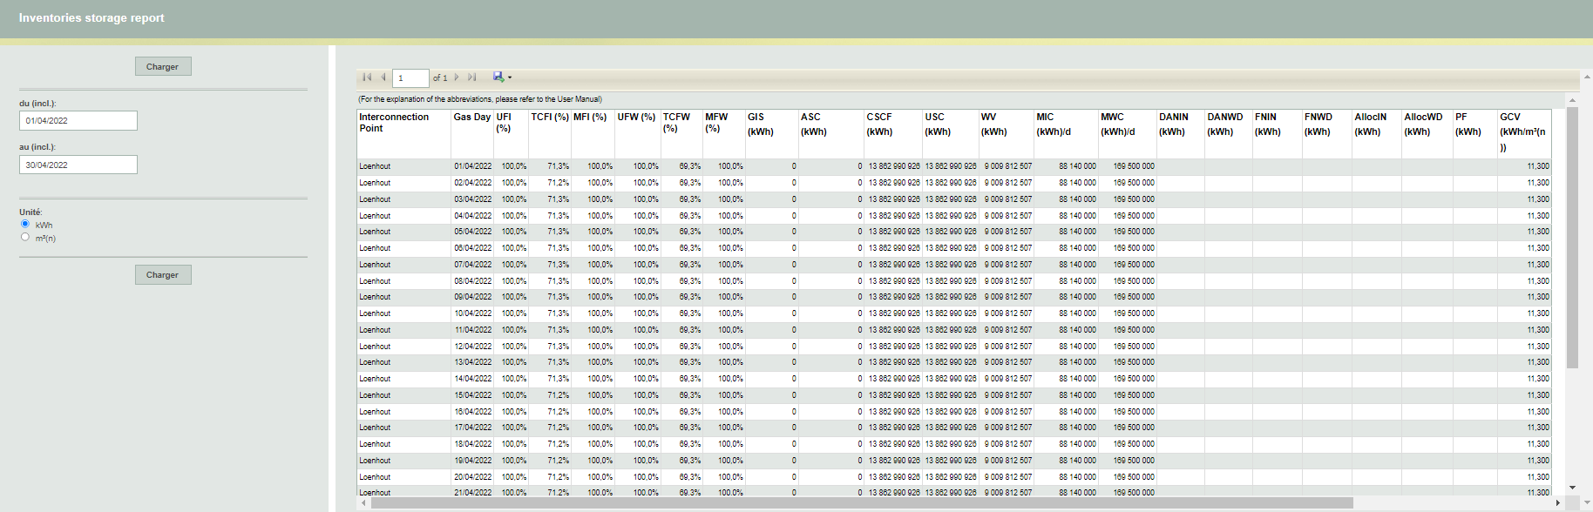

- Capacity Rights Injection - 3 months view
- For dates starting from 01/04/22 there is no data published for the columns “Conditional Subscribed Capacity” and “Subscribed Total Capacity”.
- A new column “Priority Booster Capacity” is added.
- All capacities are reported in the unit kWh/h instead of the unit m³/h. For dates before 01/04/22 a conversion from the unit m³/h to the unit kWh/h is done:
    - A fixed GCV of 11,3 kWh/m³ is used for subscribed capacities.
    - The measured GCV is used for real capacities.
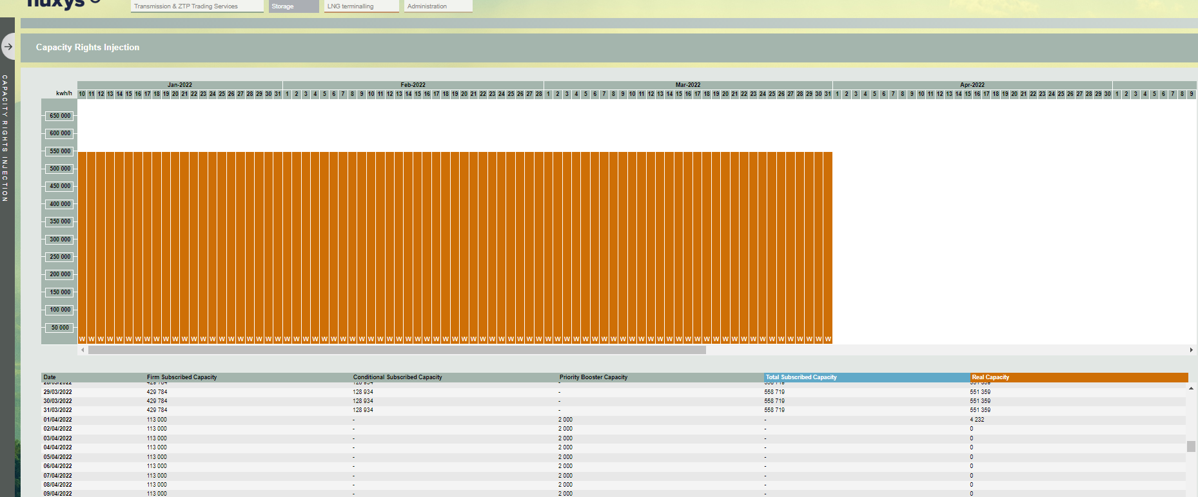

- Capacity Rights Injection - daily view
  - For dates starting from 01/04/22 the column “Conditional Factor (%)” is removed and replaced by the column “Claimed Factor (%)”. For dates before 01/04/22, the Conditional Factor is still published.
  - The column “Account Factor (%)” is renamed to “Gis Exceeding Factor (%)”.
  - The column “DAM/NNS [m³/h]” is renamed to “Booster capacity [kwh/h]”.
  - All capacities are reported in the unit kWh/h instead of the unit m³/h. For dates before 01/04/22 a conversion from the unit m³/h to the unit kWh/h is done:
    - A fixed GCV of 11,3 kWh/m³ is used for subscribed capacities.
    - The measured GCV is used for real capacities.
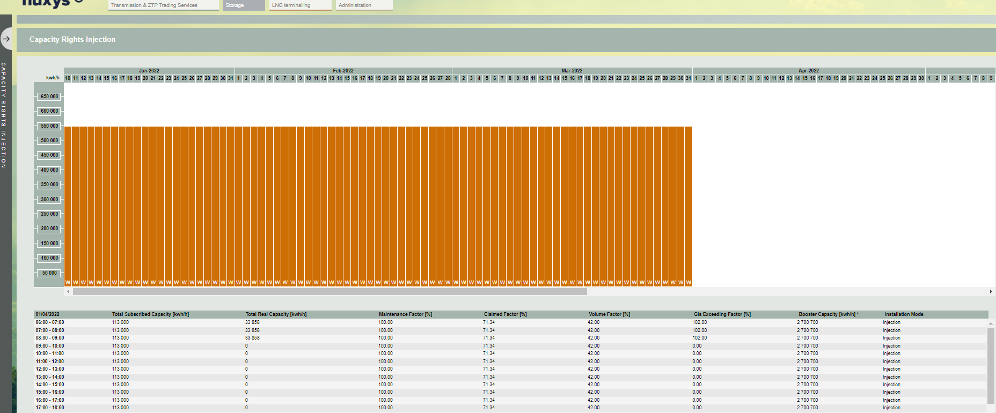

- Capacity Rights Withdrawal - 3 months view
  - The column “Firm & Conditional to Installation Subscribed Capacity” is renamed to “Firm Subscribed Capacity”.
  - For dates starting from 01/04/22 there is no data published for the columns “Conditional Subscribed Capacity” and “Subscribed Total Capacity”.
  - A new column “Priority Booster Capacity” is added.
  - All capacities are reported in the unit kWh instead of the unit m³. For dates before 01/04/22 a conversion from the unit m³/h to the unit kWh/h is done:
- A fixed GCV of 11,3 kWh/m³ is used for subscribed capacities.
- The measured GCV is used for real capacities.

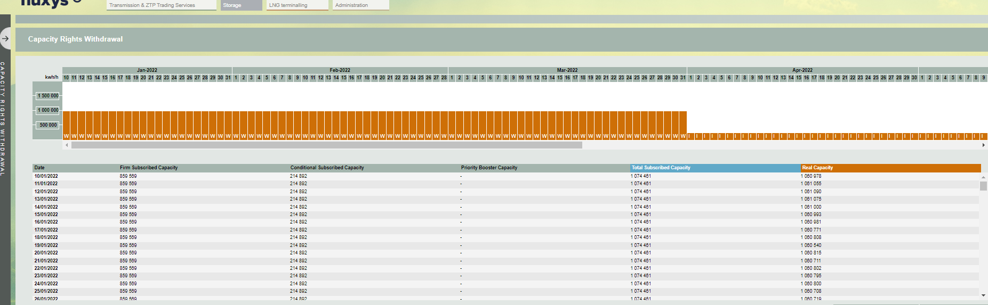

- Capacity Rights Withdrawal - daily view
  - For dates starting from 01/04/22 the column “Conditional Factor (%)” is removed and replaced by the column “Claimed Factor (%)”. For dates before 01/04/22, the Conditional Factor is still published.
  - The column “Account Factor (%)” is renamed to “Gis Exceeding Factor (%)”.
  - The column “DAM/NNS [m³/h]” is renamed to “Booster capacity [kwh/h]”.
  - All capacities are reported in the unit kWh/h instead of the unit m³/h. For dates before 01/04/22 a conversion from the unit m³/h to the unit kWh/h is done:
    - A fixed GCV of 11,3 kWh/m³ is used for subscribed capacities.
    - The measured GCV is used for real capacities.

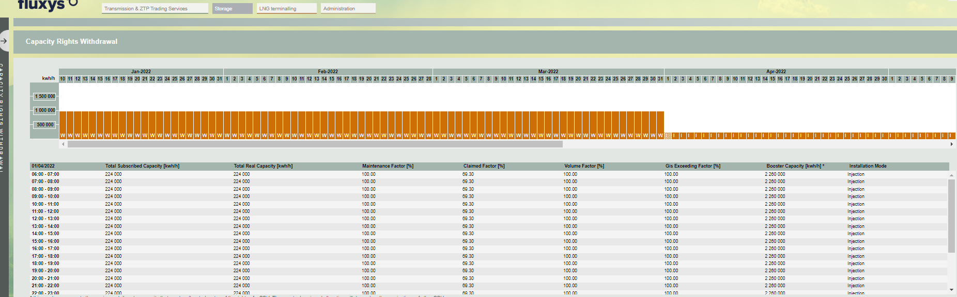

- Capacity Rights Storage
- Starting from 01/04/22 there is no data published for the column “Conditional Subscribed Capacity”.

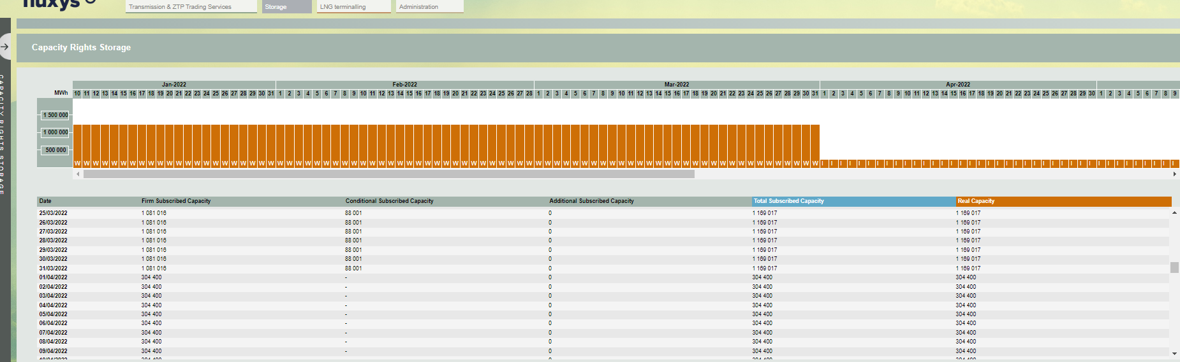

- Gas in storage forecast
  - The column “Conditional Factor (%)” is removed.
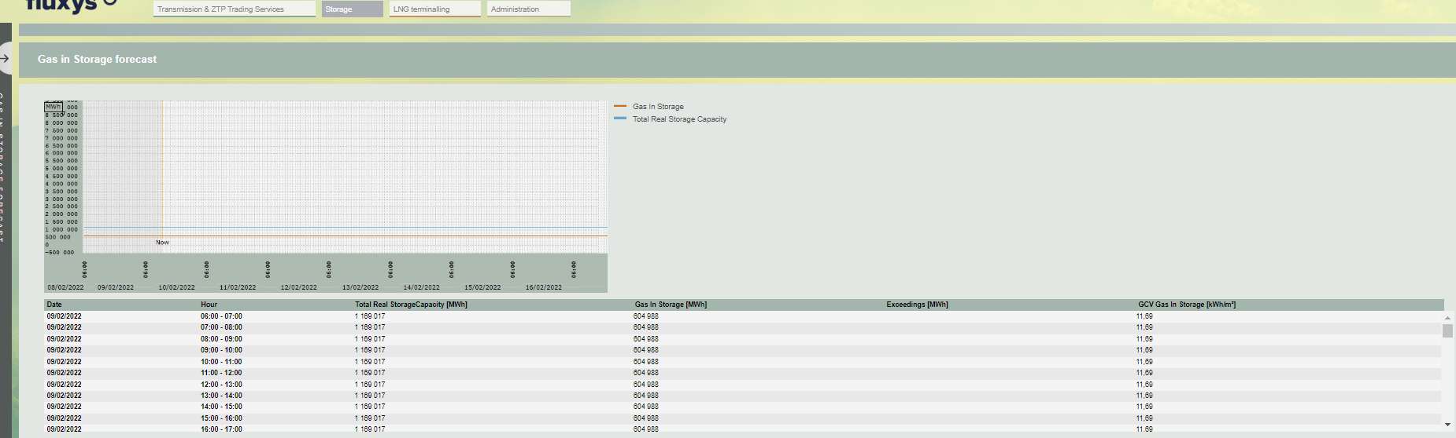

- The section “DAM – NNS reports” is renamed to “Booster reports”.
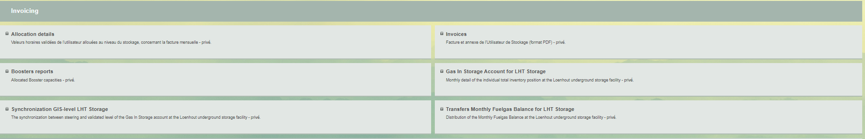

- Invoicing
  - Starting from 01/04/2022, PDF invoices and appendixes will be abandoned and replaced by Invoice XML and Invoice Detail XML files similar to those that are used for Transmission. The product codes can be found under Operational Information.

- Capacities Download
  - A new CapacityServiceNatureType “PriorityBooster” is added.
  - The CapacityServiceNatureType “Conditional” is no longer available for dates starting from 01/04/22.
  - All injection and withdrawal capacities are reported in the unit kWh/h instead of the unit m³/h. For dates before 01/04/22 a conversion from the unit m³/h to the unit kWh/h is done with a fixed GCV of 11,3 kWh/ m³.
  - Example: Samples\Storage\Examples\Capacities.xml
- RealCapacities Download
  - The FactorType “ConditionalFactor” is no longer published for dates starting from 01/04/22.
  - A new FactorType “ClaimedFactor” is added.
  - The FactorType “AccountFactor” is renamed to “GisExceedingFactor”.
  - The CapacityServiceType ”DAM/NNS” is renamed to “BoosterCapacity”.
  - All injection and withdrawal capacities are reported in the unit kWh/h instead of the unit m³/h. For dates before 01/04/22 a conversion from the unit m³/h to the unit kWh/h is done:
    - A fixed GCV of 11,3 kWh/m³ is used for subscribed capacities.
    - The measured GCV is used for real capacities.
  - Example: Samples\Storage\Examples\RealCapacities.xml

